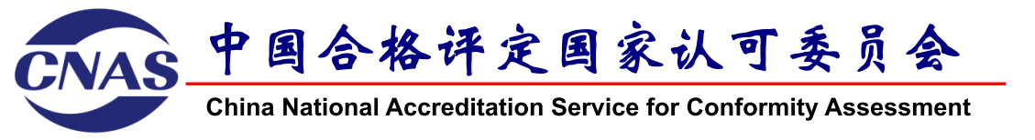

Extraction, Preservation and Analysis of Data from Computer and Server Proficiency Testing Program for Digital Forensics

**APPLICATION FORM**

Participants are required to complete the following form and **email** to the contact person below **no later than October 19, 2024.**

**Contact:**

**Ms. JIA Rujing (CNAS), E-mail: jiarj@cnas.org.cn**

**Mr. WU Songyang(SDFC), E-mail: pt@stars.org.cn**

**Information of Participant**

|  |  |
| --- | --- |
| Name of Your Body/Lab |  |
| Contact Person |  |
| Country / Region |  |
| Email |  |
| Shipping Address |  |
| Phone |  |
| Fax |  |
| Accreditation Status | Accredited (ISO/IEC 17025) ⎕  Accredited (ISO/IEC 17020) ⎕  Not Accredited ⎕ |